91 How can I develop effective problem-solving skills in my daily life? Please highlight the important words to the semantic meanings in every sentence using boldface fonts.

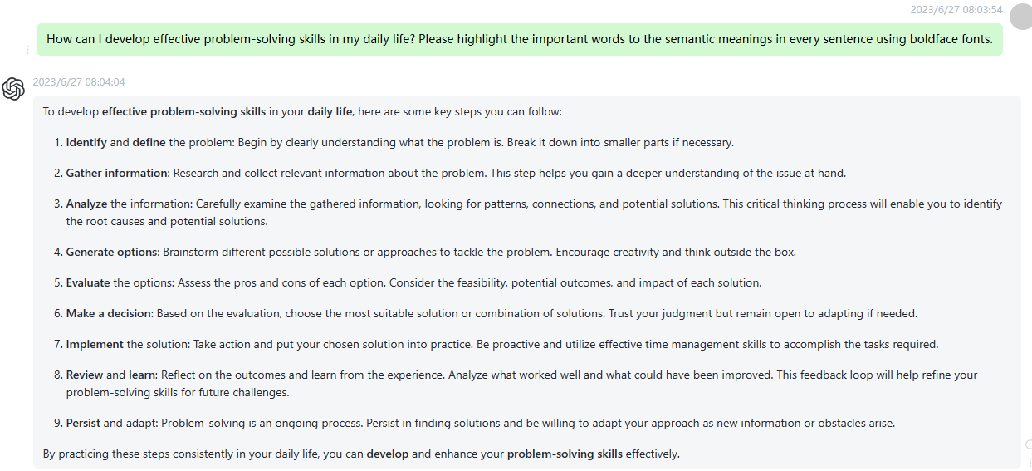

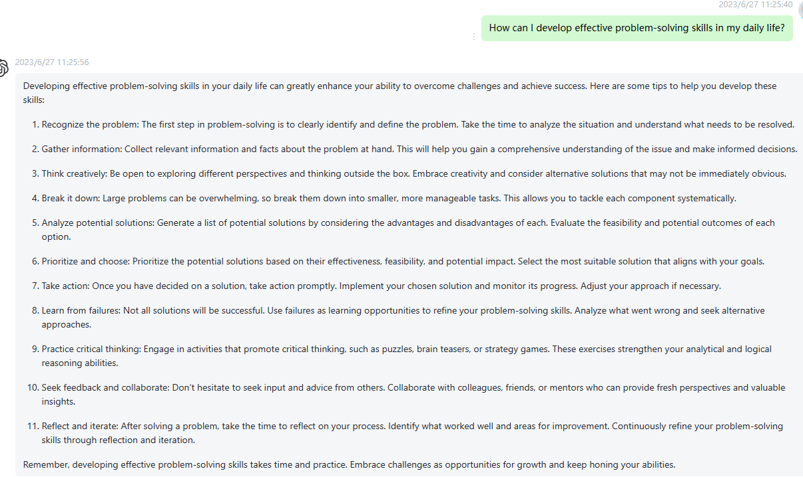

92 What are the key elements of successful business strategy formulation? Please highlight the important words to the semantic meanings in every sentence using boldface fonts.

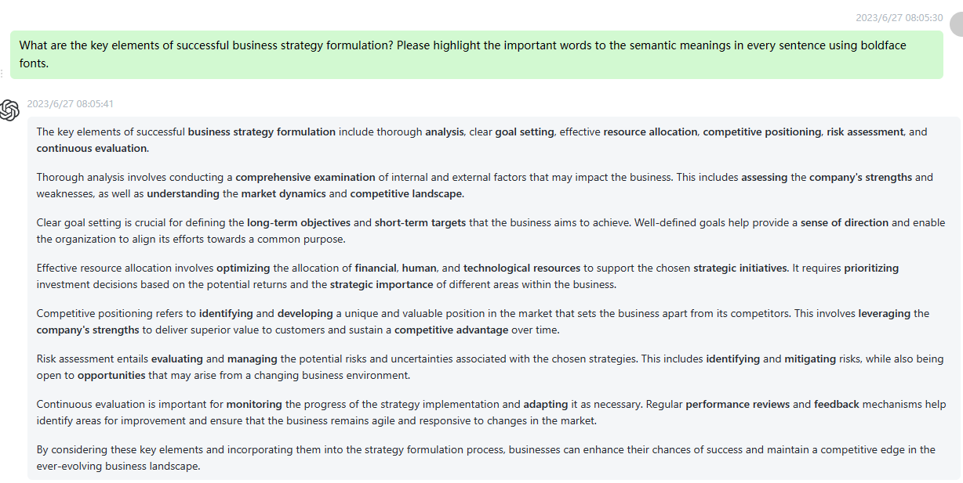

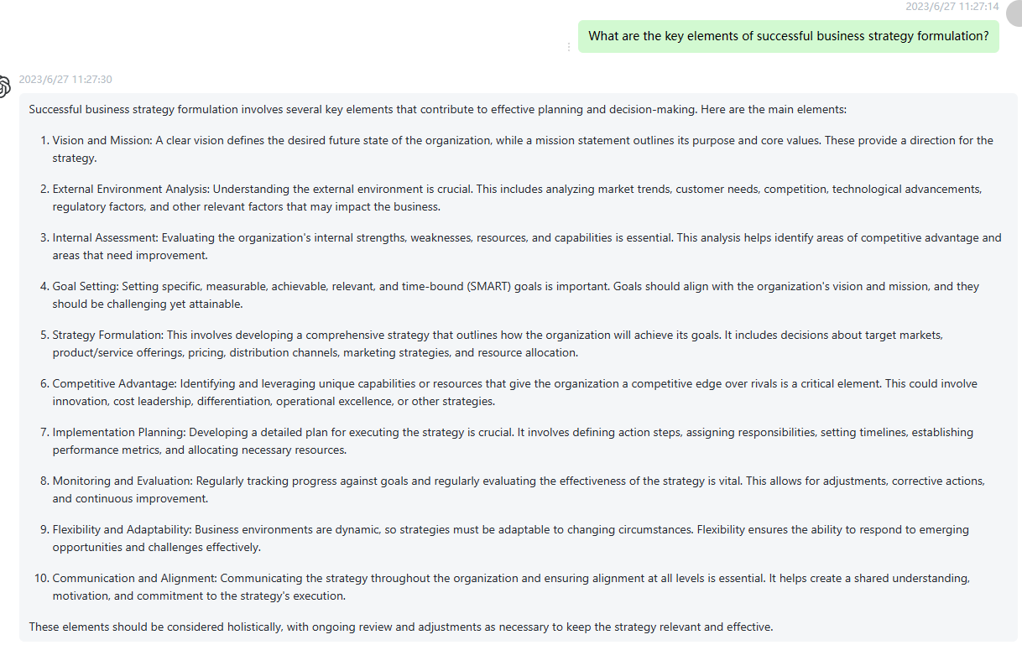

93 How can I improve my networking skills for career advancement? Please highlight the important words to the semantic meanings in every sentence using boldface fonts.

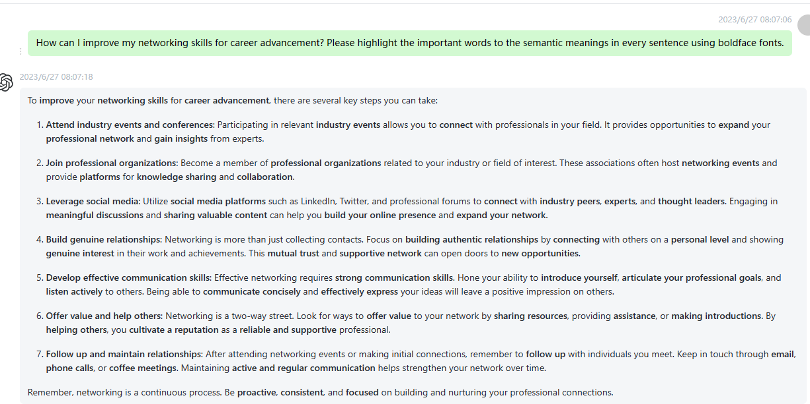

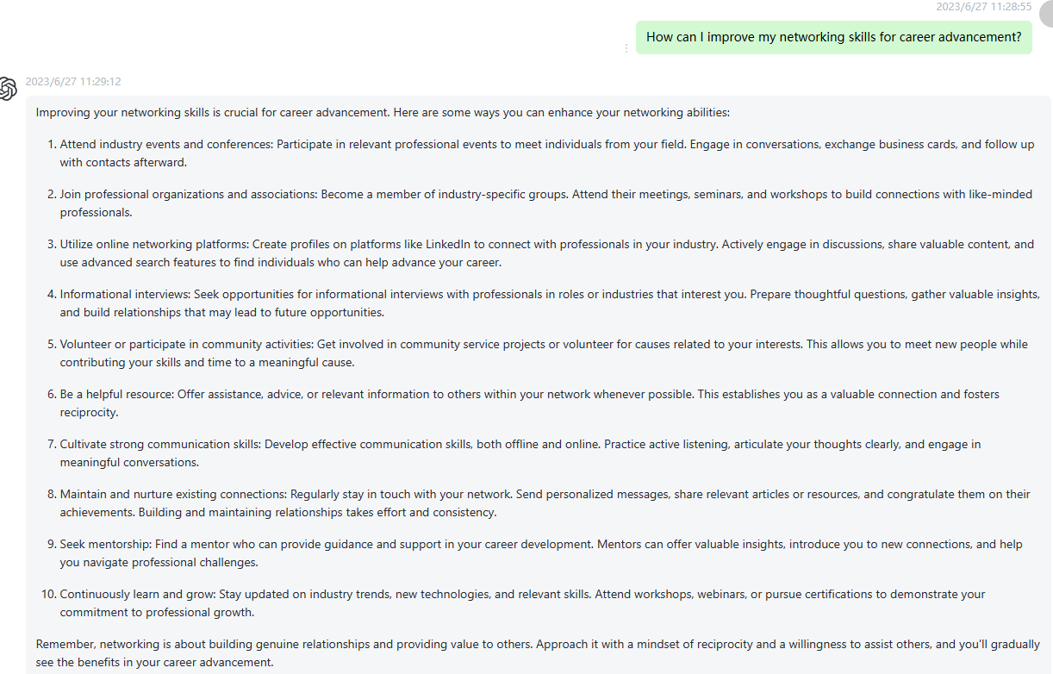

94 What are the best practices for building and maintaining strong customer relationships? Please highlight the important words to the semantic meanings in every sentence using boldface fonts.

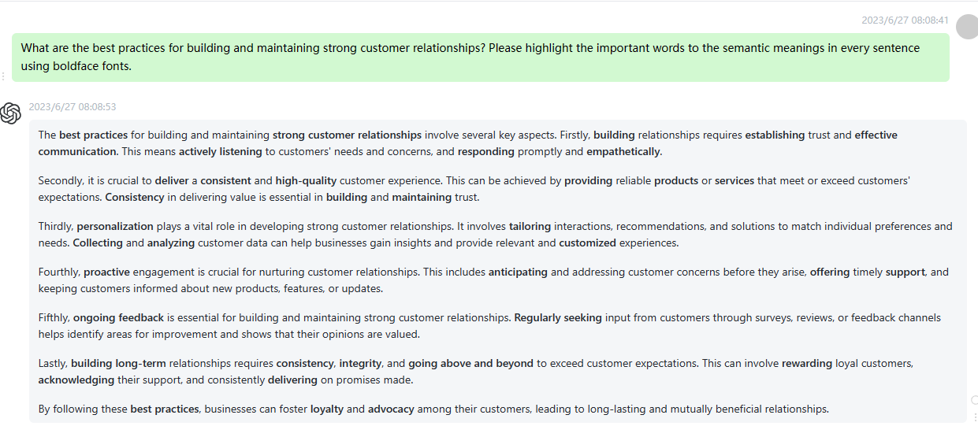

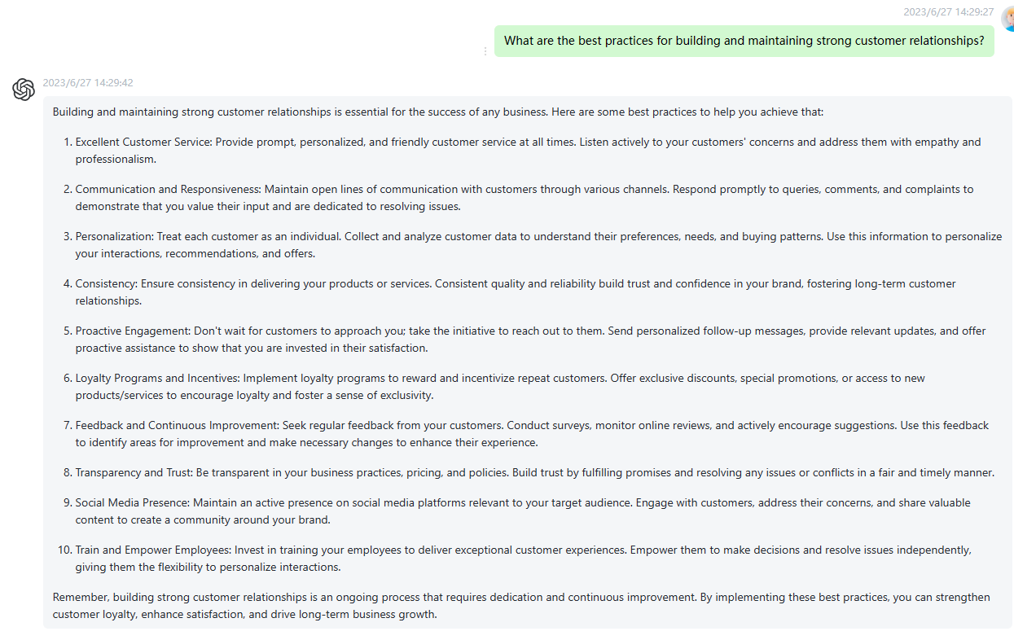

95 How can I leverage technology to streamline business operations and increase efficiency? Please highlight the important words to the semantic meanings in every sentence using boldface fonts.

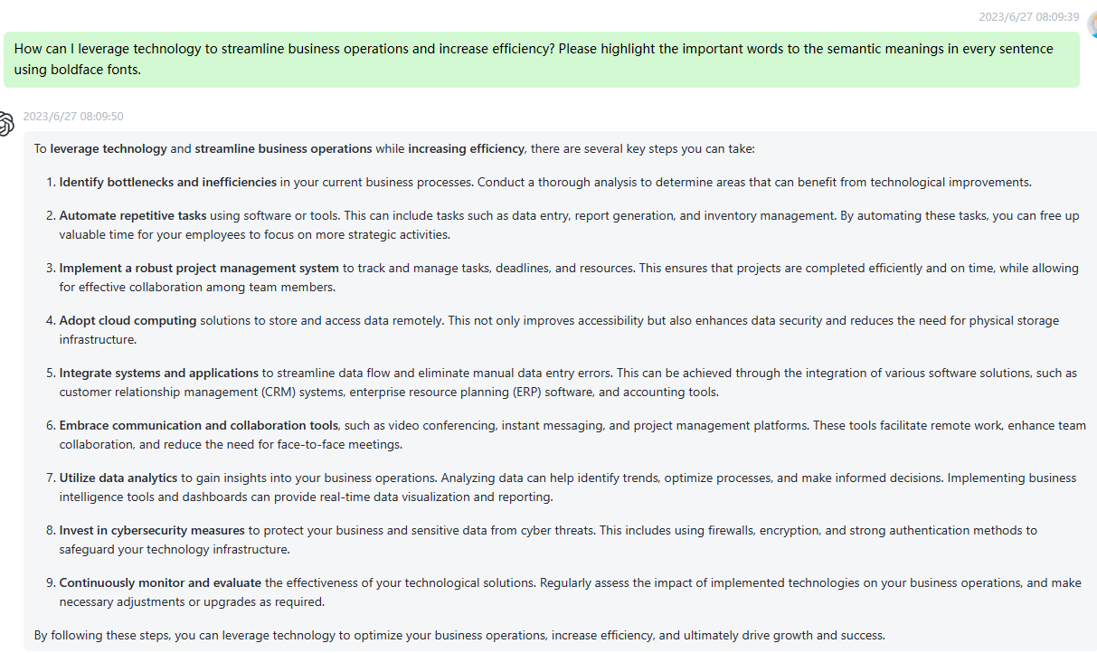

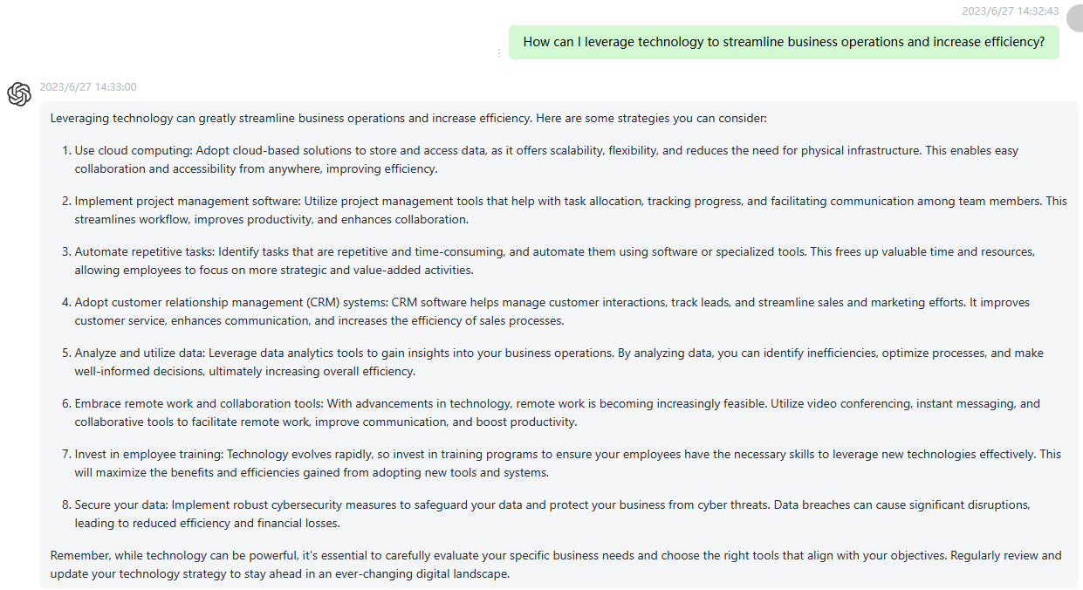

96 What are the important considerations in developing a comprehensive marketing plan? Please highlight the important words to the semantic meanings in every sentence using boldface fonts.

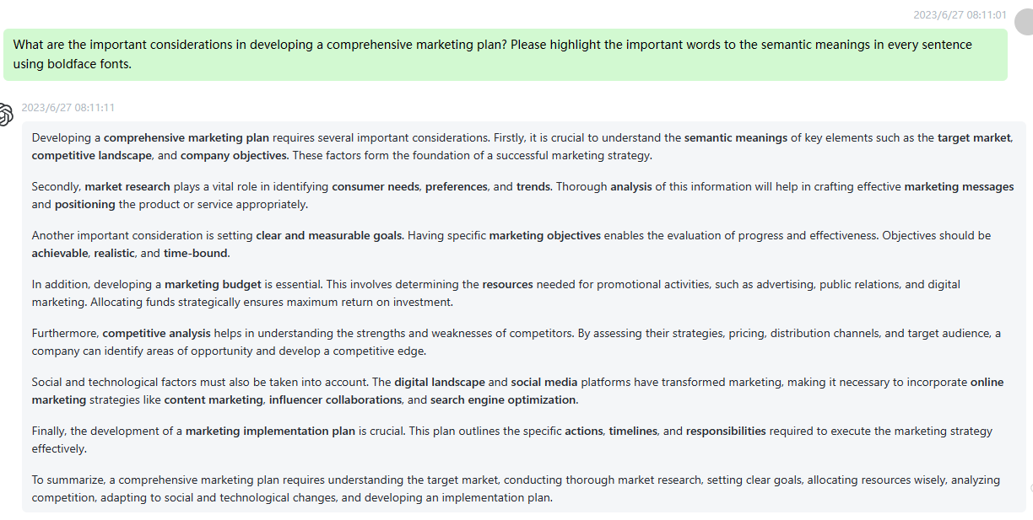

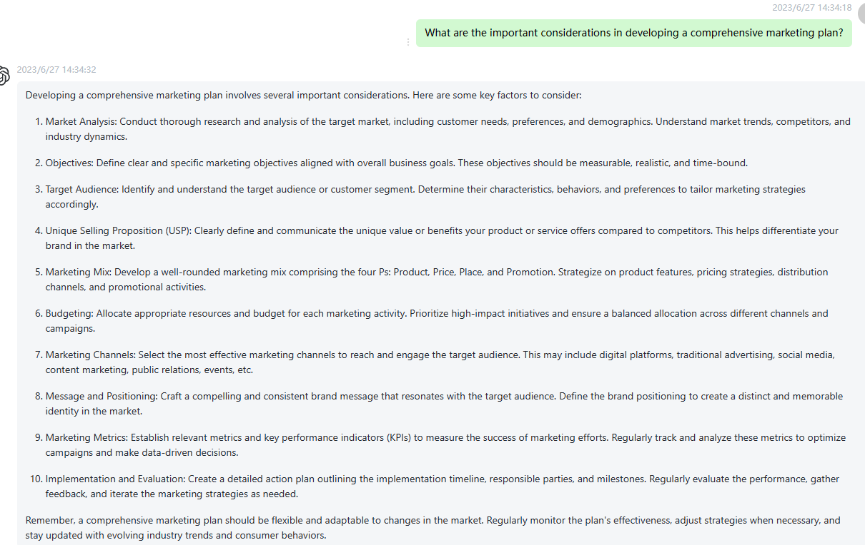

97 How can I enhance my project management skills for successful project delivery? Please highlight the important words to the semantic meanings in every sentence using boldface fonts.

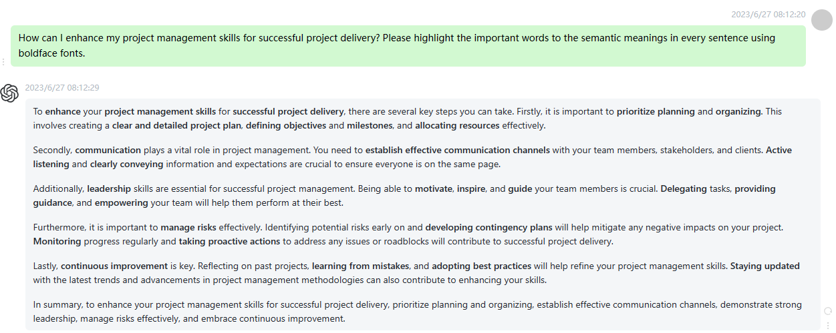

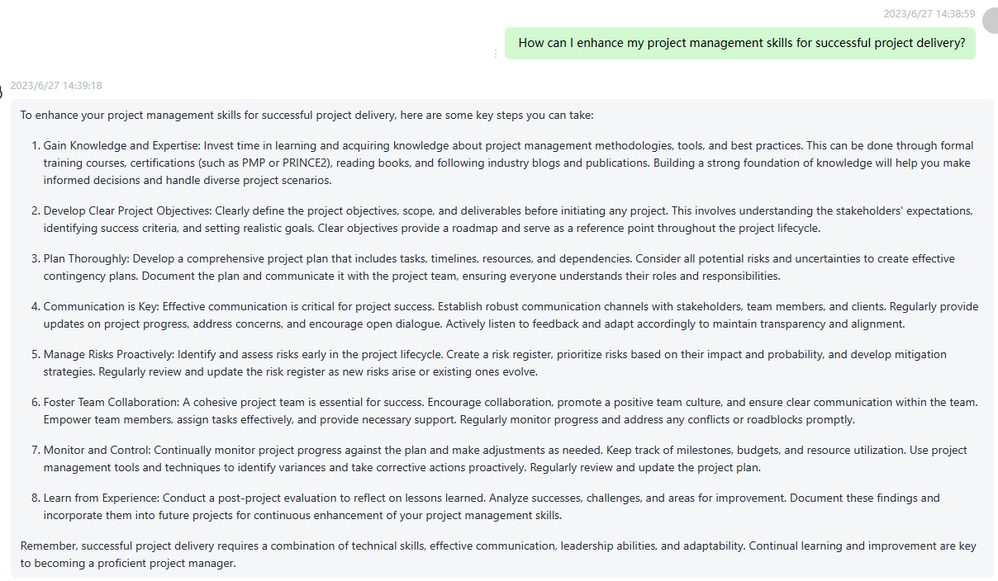

98 What are the key factors in building a resilient and adaptable organization? Please highlight the important words to the semantic meanings in every sentence using boldface fonts.

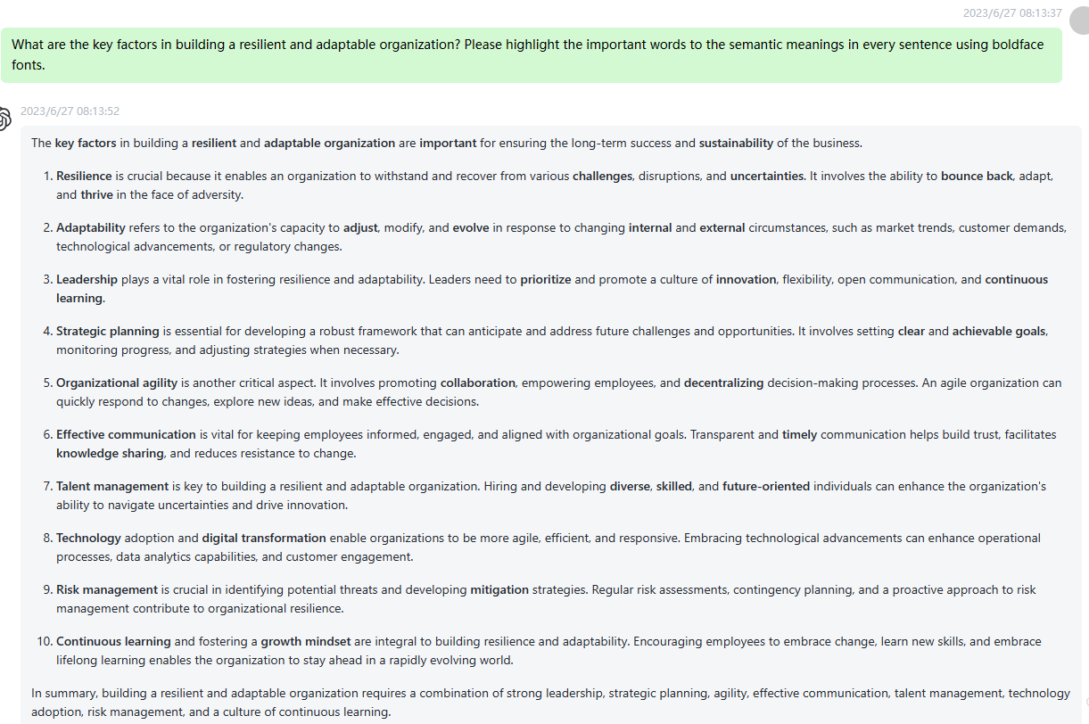

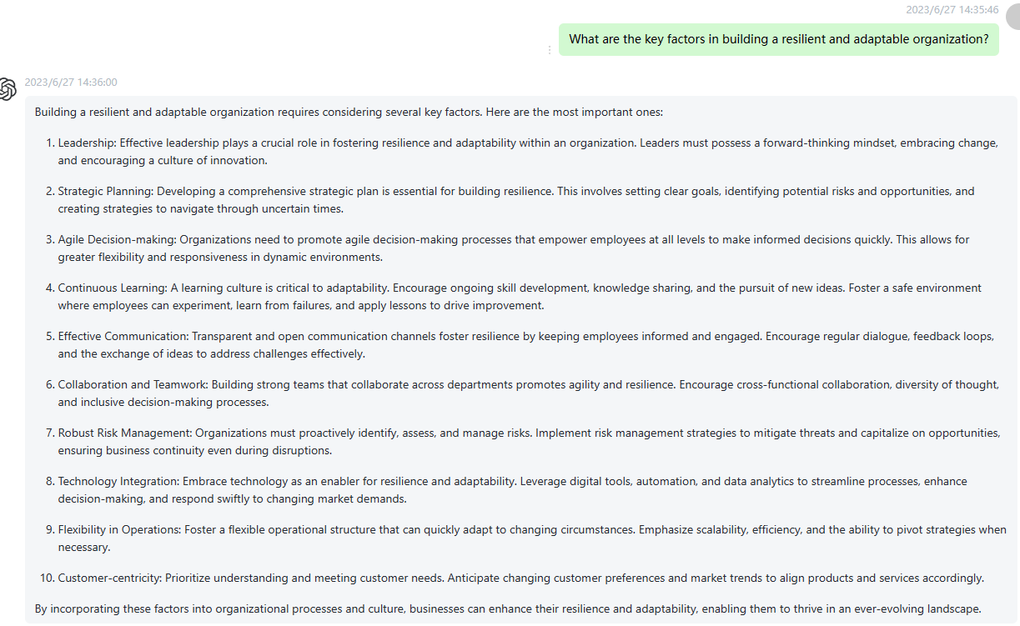

99 How can I develop effective leadership skills in a remote work environment? Please highlight the important words to the semantic meanings in every sentence using boldface fonts.

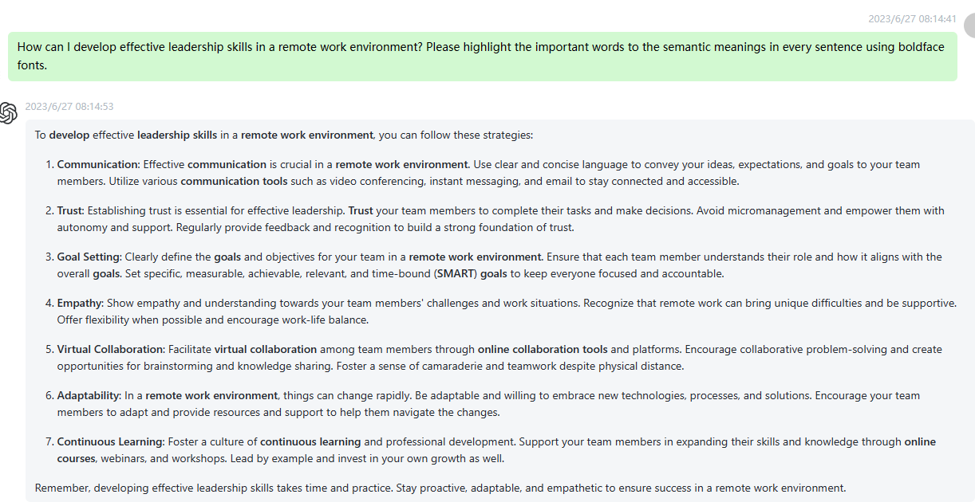

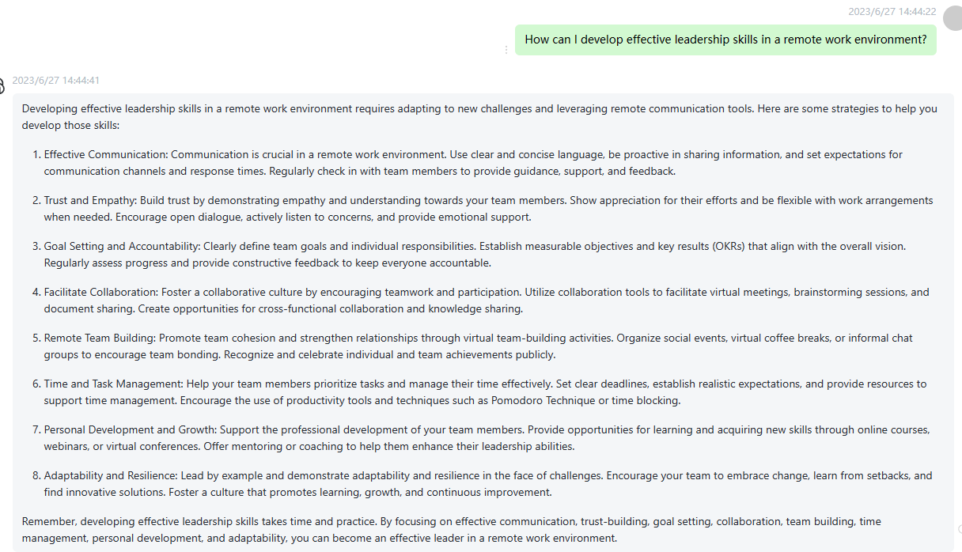

100 What are the strategies for effective conflict resolution in cross-cultural teams? Please highlight the important words to the semantic meanings in every sentence using boldface fonts.

